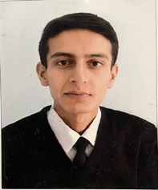
mohit kanwar.
Kanwar niwas new flowerdale chotta shimla 171002.
mohitkanwar02@gmail.com
8580735353

Objective
- To be associated with reputed company and learn good working skills and knowledge.

Experience
- 6 months of experience with aegis customer support services private limited as capacity of Executive-operations

Education
- I have done my graduation in BHM (Bachelor’s in hotel management) from Bahara University , Shimla hills
- I have done my schooling from Kendriya Vidyalaya Jakhoo Hills Shimla

Languages
- Hindi
- English

Hobbies
- Cooking
- Exploring new places

Strengths
- Hard working
- Honest
- Quick learner

Place-Shimla
Date-06 july 2022

